
Faculty of Applied Sciences
Bachelor of Science in Computing

COMP3114 Information System Project
Final Report
Academic Year 2025/26
2nd semester

Online Shopping Mall
Group number: | Your group number
Group members: | Leader name (his/her student ID)
 | 2nd member name (his/her student ID)
 | 3rd member name (his/her student ID)
 | 4th member name (his/her student ID)
 | 5th member name (his/her student ID)
 | 6th member name (his/her student ID)
Supervisor: | Your supervisor
Assessor: | Your assessor
Submission Date: | XXX XX, 2026

Table of Contents
1 Introduction 4
2 Project Management 5
2.1 Team Charter 5
2.2 Project Scope Management 5
2.3 Project Time Management 6
2.4 Project Risk Management 8
2.5 Job Distribution 8
2.6 Retrospective on Team Dynamic 9
3 Requirements Analysis 10
3.1 Analysis Scheme and Methods 10
3.2 User Requirements 11
3.3 Implemented Features of the Specification 11
3.4 [others …] 13
4 System Design 14
4.1 Architectural Design 15
4.2 Data Modelling 15
4.3 Dynamic Modelling 16
4.4 [others …] 18
5 Project Outcome 19
5.1 [A topic] 20
5.2 [Another topic] 20
5.3 [Yet another topic] 20
6 Software Quality 22
6.1 Software Verification 22
6.2 Security 22
6.3 Reflection on User Experience 22
6.4 [other qualities …] 23
7 Conclusion and Further Work 24
References 25
Appendix A. Ethics Checklist 26
Appendix B. Declaration of the Use of Generative AI 29

Table of Figures
Figure 1: PDM 9
Figure 2: Sample Entity Relationship Diagram 14
Figure 3: Sample activity diagram from Wikipedia 15
Figure 4: Sample state diagram for www.geeksforgeeks.org 15
Figure 5: Shopping UI in Amazon 18

Introduction
In the first chapter, you introduce your project by answering two key questions. 1) What is the system you’re going to build? 2) Why this system is relevant / useful to the stakeholders? Usually you start with the background and motivation.
Describe the background and motivation of this project from the perspectives of various stakeholders. This should be short, e.g. within 1 page. (Put more detailed product comparison or technical background related to system design in later chapters.) What kinds of products / services are you selling in the system? Is online sale of such products popular for business and consumers? Show some market statistics to substantiate the relevance of your project. Describe common features of e-commerce web sites / apps that are particularly important for your project.
Next, describe the general functions of your online shopping mall, which kind of products are sold, and what special considerations in problem domain, if any, are considered. You should also draw readers’ attention to unique features of your work, e.g. streamlined user shopping experience, use of modern software development process or tool, comprehensive consideration of web security in system design and testing, application of artificial intelligence technologies. Keep the description concise and high-level, e.g. within 1 page.
Finally, end this chapter with a summary of the whole report. An example is shown below.
This report is organized as follows: Chapter 2 explains the requirements of the system. Chapter 3 presents our design approach. Chapter 4 illustrates the developed system. [and so on …]

Project Management
This first paragraph should be an introduction to the content of the chapter and its purpose in the entire project.

Team Charter
A team Charter focuses on the agreements in how the team will operate and is created as a team, which typically contains:
- Project missions
- Team purpose
- Team members, their roles, responsibilities and expertise
- Communication guidelines (meeting times, face-to-face, group, email, conference calls, how often? …) (the ground rules for team cooperation)
- Decision-making process for the requirements, schedule and other issues (if your team has an argument on a project issue, how your team come to an agreement.)
- Conflict Resolution

Project Scope Management
In this section, you must identify all the activities involved to get the whole development project done. Here is an example:
Project Scope
- System Analysis
  - Ground study on the e-payment implementation of similar projects.
  - Requirement collection
    - Develop a prototype to demo…
    - Collect requirements through interviews…
    - Validate requirements specifications
    - Compile the finalized requirement specification document
- System Design
  - Design the overall software architecture.
  - Design database.
  - Design end-user interfaces on mobile phones.
  - Design interfaces for admin functions on desktop computers.
  - Design the security scheme for safeguarding the transactions over the internet.
- System Implementation
  - Create the individual web pages for the site.
  - Create database.
  - Source necessary library modules for client-side coding.
  - Server-site coding and testing
    - Code the server-site modules (system admin and operations).
    - Code the server-site modules (end-user services).
  - Client-site coding and testing
    - Code the client-site modules (system admin and operations)
    - Code the client-site modules (end-user services)
  - Integrate the server-side modules and the web pages.
  - Performance stress tests on the system
  - Have the sponsor and end-user representatives perform UAT on the system.
  - Report writing
- System Deployment
  - Install the web site on the client’s web server for operation.
  - Create technical training materials for the staff on how to use and maintain the operations.
  - Train the staff on operating and maintaining the system.

Project Time Management
Exhibit an Activity List with the fields (Activity code, Activity, Duration, and Predecessor). The activities are all the works involved in accomplishing the project. Before devising the list, you must identify all the activities involved to get the whole development project done. Although most of the functional requirements are given for this student project, you still need to identify all necessary activities as if you start everything from scratch.
Activity | Description | Duration (man-day) | Predecessor/ Dependency
1.1 | Ground study on the e-payment implementation of similar projects. | 3
1.2.1 | Develop a prototype to demo… | 4 | 1.1
1.2.2 | Collect requirements through interviews… | 5 | 1.2.2
1.2.3 | Validate requirements specifications | 1 | 1.2.3
2.1 | Design the overall software architecture | 1 | 1.2.3
2.2 | Design database | 3 | 1.2.3
…
3.4.1 | Code the server-site modules (system admin and operations) | 5
…
3.6 | Integrate the server-side modules and the web pages. | 3 | 3.4.1, 3.4.2, 3.5.1, 3.5.2
…
4.3 | Train the staff on operating and maintaining the system | 5 | 4.1, 4.2
Table 1: Activity List
Draw a PDM (Precedence Diagramming Method) based on the Activity List. The PDM should be further specified with the 4 dates (early start, early finish, late start and late finish) for each activity. Exhibit the critical path(s).

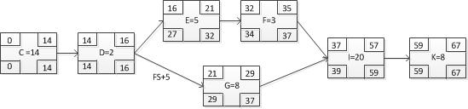
Figure 1: PDM

Show the schedule in the form of Gantt Chart. Note that the left side of the Gantt Chart must match with the Activity List. Show the Gantt Chart in a readable form.

Project Risk Management
Assess the potential project risks for your project and devise appropriate risk responses to each identified risk. A project risk is the one that poses negative impacts (don’t discuss the positive risks) on the project goals (achieving the target scope, time and cost). You must give 3 relevant, non-trivial potential risks and assess them as the given example below. A “non-trivial risk” means the risk having a significant value in at least one of the two aspects of risk assessment (probability and impact).

Risk 1: The crash of the storage hard-disk
- Description: xxxxxxx (general description of the risk; description of what causes you to perceive this as a risk; etc.)
- Probability of occurrence: low to medium level (low/medium/high)
- Impact: It is disastrous that all program codes and data xxxx, leading to xxxxx (how this affects your project goals)
- Response: xxxxxxx (the strategy to resolve the difficulties caused by the risk)

Job Distribution
Provide a list of activities (Activity List) with the percentages of the contributions for all members. An activity may be shared among more than one member. An example for a group of four is given below.
Member 1: [name] (Overall contribution percentage: 30%)
- Planning the project schedule and task allocations (80%)
- Data modelling. (50%)
- User requirement analysis
- …
Member 2: [name] (Overall contribution percentage: 30%)
- Coding: Block B (functions 1-5)
- Testing: Block B(functions 1-8)
- …
Member 3: [name] (Overall contribution percentage: 20%)
- Coding: Block A (function 1,2..)
- Report writing: chap 1, 2, 3.
- …
Member 4: [name] (Overall contribution percentage: 20%)
- Coding: Block A (functions 4,5,7)
- Testing: Block A (functions 1-10)
- Data modelling. (50%)
- Report proof reading
- …

Retrospective on Team Dynamic
Provide an overview of your team formation and reflect on the communication and coordination that occurred during the project. What challenges did you face, such as language barriers, different backgrounds, scheduling conflicts, team coordination, or differences in skill levels and skill sets? How did these issues impact your work? How did you do to tackle the issues? Are there any strategies would you implement if you encounter similar challenges in the future?

Requirements Analysis
In this chapter, you explain how you determine the needs or conditions that your developed system will meet. The first three sections are required. Section 2.1 covers the requirements on system features. Section 2.2 covers the user requirements. Section 2.3 lists the basic requirements in the System Specification that your team has chosen and successfully implemented, and summarizes your work related to any further requirements.
Depending on your project scope, you may add more sections to elaborate other aspects of requirements analysis. Below are some examples.
- Requirement of advanced functions. Explain the rationale behind your design of some advanced functions and the potential user groups of your system. What are their concerns? For example, product recommendation can help consumers to discover products of interest among a huge number of products, and user generated content (e.g. comments) inform potential purchase from new consumers and help them evaluate the product quality. Take another example, ease of use, amount of information shown in one page, age group, visual impairment, device variety and capability, all of these may lead to the requirements of some advanced features.
- Business requirements. Some non-functional requirements are important for business. Search Engine Optimization increases the visits of potential customers from web search engines. Information security measures protect the business data and minimize the downtime of the online business. Explain the importance of these features to the business.
- Societal and environmental considerations: In the development process, you can take into account the societal and environmental needs to ensure responsible and sustainable practices. Describe the measures you have implemented to mitigate potential issues and contribute to positive change. For example, the system may promote environmental awareness by encouraging the reduction of disposable plastic cutlery consumption. An online store that sells tobacco and alcoholic beverages also need to ensures strict adherence to relevant local laws and regulations.

Analysis Scheme and Methods
In chapter 1, you mentioned the kind of products your system is selling. In this section, describe how you come up with the common and specific features of e-commerce web sites / apps that are particularly important for your project. Are there any particular methods for gathering information for establishing a system specification? How do you proceed with your analysis scheme?
Do you take some related system / web sites as reference in requirement analysis? Which are these systems? Describe reference systems that are used in the modelling and design. Which features of your system are modelled after these web sites? Did you make some changes to make the features simpler to use, or more suitable for your products? (For example, consumers who buy books have different concern from those who are buying mobile phones.)
You may have identified more system requirements than you can fulfil in this project. State clearly which requirements have been fulfilled in your developed system. If appropriate, state in which sections in this report the reader can find more information.

User Requirements
In this section, identify the user groups who will use the system and outline their specific requirements. Explore common use cases and their special concerns. The exact functional requirements, which are listed as blocks in the system specification, will be documented in Section 2.3. Therefore, in this section, focus on other issues.
User requirements will define and affect different aspects of the system development. Some examples are user experience (UX), information security, service guarantee, and customer feedback. You can employ different methods to gather insights and feedback from potential users, e.g. user interviews, user observation and analysis, reflection on user experience in related works.
You may have identified more user requirements than you can fulfil in this project. State clearly which requirements have been fulfilled in your developed system. If appropriate, state in which sections in this report the reader can find more information.

Implemented Features of the Specification
In this project you are required to design and implement a certain number of basic requirements and further requirements as described in the System Specification. This section provides a consolidated account of the fulfilment of these requirements.
For the basic requirements, you must clearly list the blocks (e.g. block A, B, C) for which you have completed the implementation. If you did not complete all items in a block, list the missing one. Keep the description concise here. You can refer the readers to the system specification for detail.
Design and implementation of the further requirements are not required in this project in order to achieve a passing grade. However, you must fulfil a certain number of the further requirements to obtain a high grade. In addition to the implementation detail, you are expected to explain how the further requirements are addressed in other project tasks. In this section, you provide a summary of your work on each further requirement, and list the sections in this report that provide more information.
Use a table similar to the following to describe your selection of the basic and further requirements, their completion status, and relevant sections in this report for more information.
Block | Completion status and relevant sections in this report
A | All items implemented
B | All items implemented
C | All items implemented except C5
NF1 Accessibility | The system UI supports both Chinese and English, and a user can switch the UI language in user settings. Product description is also provided for both languages. More information can be found in the following sections.  section 4.2: bilingual product attributes in data modelling  section 4.5: implementation of bilingual interface using Django  section 5.3: user interface
NF4 Web app security | The system uses the standard Django’s security feature to realize XSS protection, CSRF protection and SQL injection protection. In addition, we deploy the system behind a reverse proxy which blocks common web attacks. More information can be found in the following sections.  section 2.4: web security requirements  section 4.1: system architecture with reverse proxy  section 4.4: configuration of reverse proxy  section 6.1: test cases related to XSS, CSRF. intrusion detection testing  section 6.2: security features in the system

[others …]
Add sections to organize your content if needed.

System Design
This chapter focuses on designing a system that satisfies the needs and considerations outlined in the previous chapter. The design process typically begins with high-level designs, which are closer to the business data and features exposed to users. From there, the discussion progresses towards lower-level details, explaining how to effectively implement these designs using suitable development tools and techniques.
Start this chapter with a paragraph that introduces the content of the chapter, describing the sections and preferably relating them into a coherent overall design of the whole system. Some typical sections are the following.
1. Architectural design describes the high-level structural model of your system.
2. Data modelling describes the structure of your database (and how you store other data like images), and the reasoning that support your design.
3. Dynamic modelling explains the dynamic aspect your system, i.e. how your system changes and react when a user carries out some function.
You may change the section titles as needed, or break a long section in several. The ordering of the sections here is just a suggestion. Discuss with group members to determine a logical order.
Depending on the basic and further requirements you have selected from the Project Specification, you may have done some sophisticated design work on some aspects or features. Use a separate section to explain your design. Below are some plausible sections.
4. Mobile UX design: How the UI is optimized for mobile device? What are some considerations in the design of the protocol between the mobile client and the backend server? How are web standards used to improve the accessibility?
5. Search engine optimization: special consideration in the system design to make the page content easier for search engine to index? Structure of the URLs referring to products.
6. Web application security: Server-side data encryption. Mitigating of common web application attacks. Data security and backup.
7. Product recommendations: Describe the algorithm used to recommend products. What user and product data are used? Other design in UI to facilitate product discovery?
8. Reports and analytics: Report design, with reference to related products. Special consideration in database design to accelerate analytics report generation.
In these sections, avoid including long or trivial code listings. You may include some programming code but show only the challenging or more interesting ones. Some cases that are worth of explaining are:
- Code pieces that are especially critical for correct system operation.
- Non-standard, innovative way (algorithm, data structure) to solve a problem.
- Unforeseen problems in implementation, and how you overcome them.

Architectural Design
Describe the high-level structural model of your system, e.g. three layers, relationship between browser, server, and database, any JavaScript running on browser-side, any stored procedure running in database system.
Next, describe the development tools and environment employed in your system. For instance, specify the programming languages used on the server-side, any libraries utilized for file uploads, and whether you leverage any Web UI frameworks like Bootstrap. Additionally, indicate the database system you have chosen to employ.
Explain your technical choices and provide reasoning behind each decision. For instance, if there are multiple Web UI frameworks available, explain the factors that influenced your selection. It would be helpful to include background information about the development tools and environment to provide suitable context for understanding the rationale behind your choices. Remember to include references in the "References" section to allow readers to access further information if desired.

Data Modelling
Describe considerations in data modelling (e.g. what are important entities? Are there any many-to-many relationships and how do you model them? How do you track the progress of a transaction in database?) Use ER diagram / UML model to illustrate your database schema. Also describe the format of files imported or exported by your solution. Give rationale behind your design. Examples: How does price change affect the data model? If a user can write review for the same product only once per purchase, does your database model enforce this relationship?
Describe your diagram and refer to your diagram in text. The following is an example. Refer to the figure (e.g. Figure 1 shows …) in your text.
Figure 2 shows the entity relationship diagram of the database of this project. The entity COURSE represents a course with a given name and course number, and a course may have 1 or more classes. A class is represented by the entity CLASS. It includes …
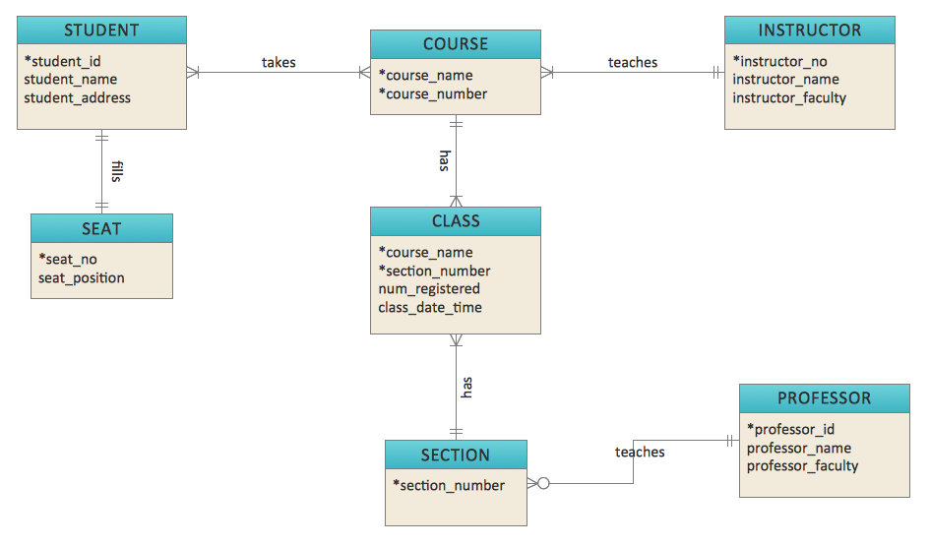
Figure 2: Sample Entity Relationship Diagram

Dynamic Modelling
Explain the interaction or dynamics of your system (e.g. state change of a purchase order, transfer of data in different state of a purchase order.) You may use activity diagram, sequence diagram, state diagram, etc.
Activity diagrams are commonly used to describe the flow of activities in a system or a process. An example is given in Figure 3. You must write a paragraph (or more) to explain the sequence and steps in the activity diagram. When the activity diagram includes many paths from the start to the end, you can help the reader to understand better by explaining the most common path first. Afterwards, describe the auxiliary paths and loops.

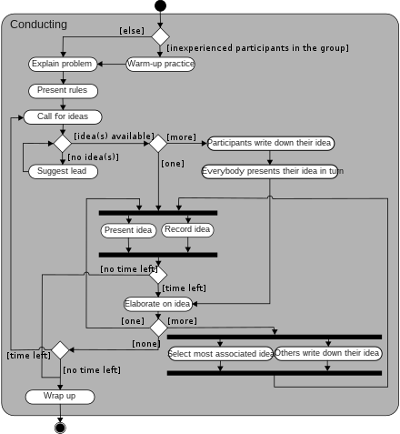
Figure 3: Sample activity diagram from Wikipedia
Another common kind of diagram in dynamic modelling is State diagrams. For example, you can use a diagram like Figure 4 to describe permissible transition between states of a purchase order and the events that trigger such transition.
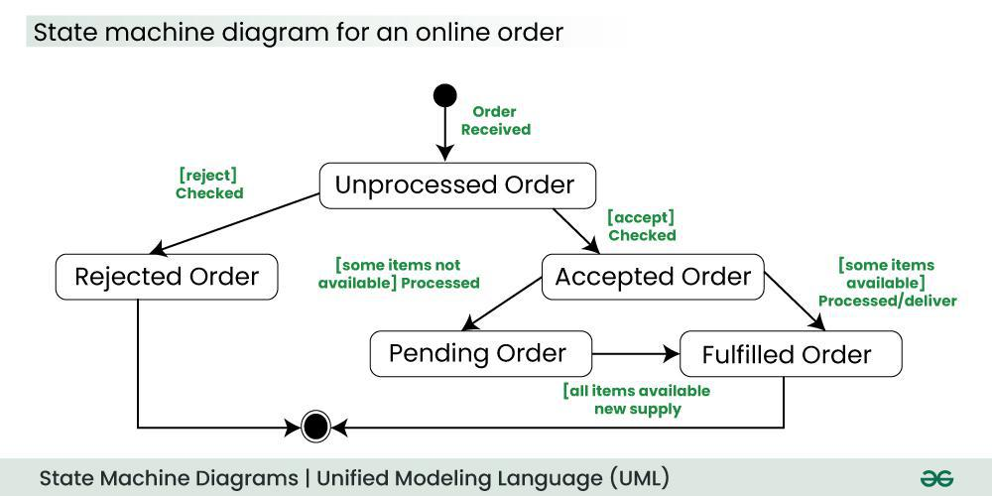
Figure 4: Sample state diagram from www.geeksforgeeks.org

Make sure small text in diagrams is readable when printed on A4 paper.

[others …]
This is the space for your group to exhibit your findings and design details from your study on the Advanced Feature(s) or Non-Functional requirements you have chosen.

Project Outcome
This chapter, together with the demonstration video, describes the project outcome, your developed system. Their different roles are as follows.
- The demo video illustrates the working of each item in the selected blocks of basic requirements. You must label each part of the video clearly with the item code, e.g. A1, A2. If you have completed some further requirements, you should also illustrate them in the demo video. The video content should agree with Section 2.3 “Implemented Features of the Specification”.
- This chapter describes the system features on a higher level. It DOES NOT repeat all the content of the video. In addition, you can provide a deeper explanation of some system features.
You should describe the major non-trivial functions with captured screen images or other diagrams/figures in this chapter. Make sure that the text in the images is readable when the page is printed on A4 paper.
You DON’T need to describe every function with captured screen images in this chapter. Focus on the major functions. Refer to the demonstration video for others where appropriate. As an example, the login process is usually simple, and is better explained in the video instead step-by-step short description with several screen captures. Moreover, you DON’T need to describe each minor step in a process with captured screen images. In most cases, text description is enough. This chapter SHOULD NOT be written as a user guide.
Organize the content of this chapter in a logical coherent flow. For example, you should explain the progress of a transaction as performed in your system. Organize your description in a logical coherent flow. For example, you can explain the steps of a purchase from product searching to shipment in a section, and then the catalogue maintenance in another section. Alternatively, you may separate customer’s features from vendor’s features.
This chapter, together with the demonstration video, should be detail enough for evaluating how well you have implemented all the items listed in Section 2.3. This enables your assessor to fully understand the project outcome without a system demo. You should also include sample report layouts (if applicable).

[A topic]
Sample text sample text sample text. Sample text sample text sample text sample text sample text. A sample list below:
- Sample list item
- Sample list item

[Another topic]
Sample text sample text sample text. Sample text sample text sample text sample text sample text.
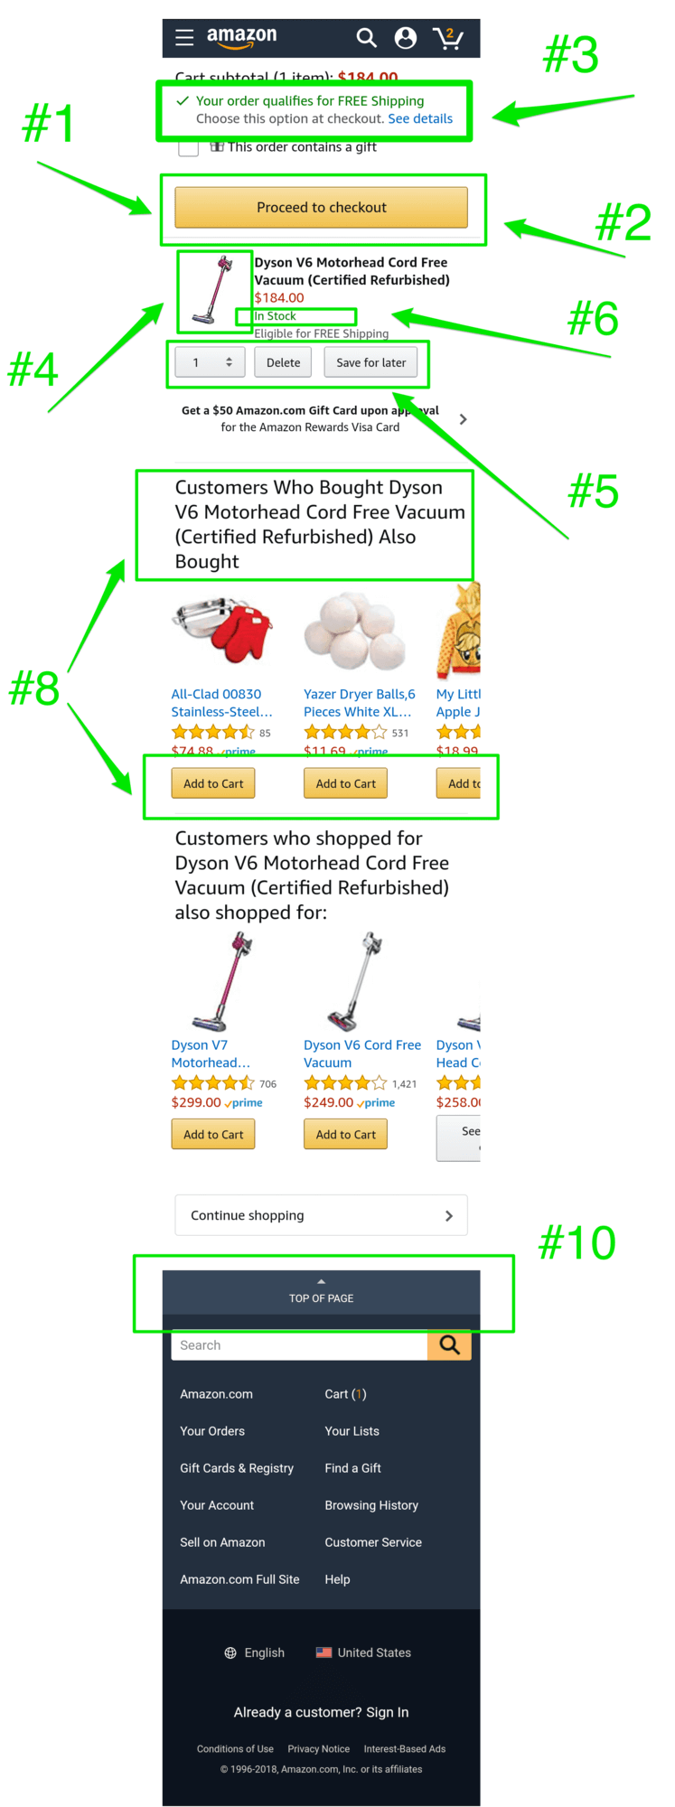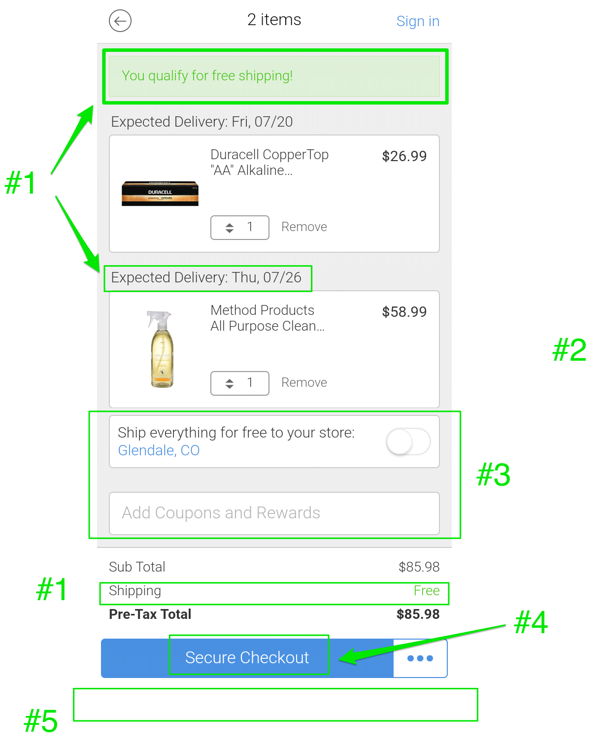
Images from https://www.growcode.com/blog/mobile-shopping-cart-design-mcommerce/
Figure 5: Shopping UI in Amazon

[Yet another topic]
Sample text sample text sample text. Sample text sample text sample text sample text sample text.
Sample text sample text sample text sample text sample text. Sample text sample text sample text sample text. Sample text, sample text: sample text, sample text sample text. Sample text sample text.

Software Quality

Software Verification
Describe the software testing approach employed by your group to ensure the correctness of the system, including the responsible group members for running the tests and whether manual or automated testing is conducted. Specify the types of tests applied, such as debugging techniques, unit tests, integration tests, and acceptance tests.
Explain the design of test cases and/or the utilization of requirement-based tests. Elaborate on how you ensure the implementation of major, non-trivial functions with adequate data validation and error checking. Additionally, describe the sample data used to test the robustness and correctness of your system, while avoiding repetitive testing.

Security
Identify security vulnerabilities and implement suitable mitigation measures throughout the developed system, encompassing aspects such as data security, and protection against malicious user input, cross-site scripting (XSS), and cross-site request forgery (CSRF). In this section, provide an overview of these security measures from an external perspective of the system. Further design decisions and implementation details of these security measures should be provided in Chapter 4.
If you have conducted any relevant system tests, such as stress tests to assess resistance against DoS attacks, provide a description of the test results in this section.

Reflection on User Experience
In this section, reflect on the user experience of your system as it relates to various demographics of potential users, including different age groups, cultural backgrounds, and abilities (such as visual impairments and motor disabilities). Discuss the design considerations implemented to create an inclusive system that meets the needs of a diverse user base. Highlight any accessibility features and standards that were integrated into your design, and explain how the testing process actively involved users from different backgrounds to ensure the system's effectiveness and usability for all.

[other qualities …]
Identify other qualities for your software system and justify why the identified qualities should be concerned. Besides, define the required level of each identified quality and suggest ways to ensure the level of quality to be reached.
This is the space for your group to exhibit your findings and design details from your study on the Non-Functional requirement(s) you have chosen.

Conclusion and Further Work
Conclude your work in 1 or 2 pages.
Summarize your work and show that the system you’ve developed satisfies the requirements that you identified at the start of the project.
Describe limitations and suggest future works. For example, if your system does not have a feature X, how can you extend it in the future?

References
[1] Harold Abelson, Gerald Jay Sussman, and Julie Sussman. Structure and Interpretation of Computer Programs. MIT Press, Cambridge, Massachusetts, 1985.
[2] Robert Baumgartner, Georg Gottlob, and Sergio Flesca. Visual information extraction with Lixto. In Proceedings of the 27th International Conference on Very Large Databases, pages 119–128, Rome, Italy, September 2001.Morgan Kaufmann.
[3] Ronald J. Brachman and James G. Schmolze. An overview of the KL-ONE knowledge representation system. Cognitive Science, 9(2):171–216, April–June 1985.
[4] Georg Gottlob, Nicola Leone, and Francesco Scarcello. Hypertree decompositions and tractable queries. Journal of Computer and System Sciences, 64(3):579–627,May 2002.
[5] Georg Gottlob. Complexity results for nonmonotonic logics. Journal of Logic and Computation, 2(3):397–425, June 1992.
[6] Hector J. Levesque. Foundations of a functional approach to knowledge representation. Artificial Intelligence, 23(2):155–212, July 1984.
[7] Hector J. Levesque. A logic of implicit and explicit belief. In Proceedings of the Fourth National Conference on Artificial Intelligence, pages 198–202, Austin, Texas, August 1984. American Association for Artificial Intelligence.
[8] Bernhard Nebel. On the compilability and expressive power of propositional planning formalisms. Journal of Artificial Intelligence Research, 12:271–315, 2000.
[9] Ivan Marsic. A short guide for writing a thesis. http://www.ece.rutgers.edu/~marsic/thesis-guide.html, 2004 [Mar. 6, 2014].
[10] Matlab documentation. http://www.mathworks.com/help/?s_tid=hp_ff_s_doc [Mar. 6, 2014].
[11] George Sparling. Spacetime is spinorial; new dimensions are timelike. arXiv:gr-qc/0610068v1, 2006.
[12] Ryan Rifkin. Everything old is new again: a fresh look at historical approaches in machine learning. Ph.d thesis, MIT, 2002.

Appendix A. Ethics Checklist
Name of student:
(leader of the team, if applicable)
Student number:

Programme: | BSc in Computing BSc in AI
Module:
Title of project:
Supervisor:

Instructions
Answer the following questions honestly. If your answer falls into a shaded box, you must provide additional information on how you will handle the related ethics issues on the last page of this form.

Project summary
Please provide more information on your project/dissertation proposal below (100-200 words).

Participants (Consent procedures and possible harm)
 |  | Yes | No | N/A
1 | Does your project include human participants?  If no, you can skip the rest of this section.
2 | Will any of the participants be from vulnerable groups, e.g. children under 18, people with communication difficulties, patients in hospital?  If yes, please specify: _______________________
3 | Will you tell participants that their participation is voluntary?
4 | Will you obtain written consent for participation?
5 | Will you tell participants that they may withdraw from the research at any time and for any reasons without penalty?
6 | Is there any realistic risk that any participants could experience either physical or psychological distress or discomfort?

Data Protection
 |  | Yes | No | N/A
7 | Will any non-anonymised and/or personalized data be generated and/or stored?
8 | Will you have access to documents containing sensitive data about living individuals?

Researcher Safety
 |  | Yes | No | N/A
9 | Will you be exposed to any risks greater than those encountered in their normal study/working life? E.g. operation of non-standard equipment or extended
10 | Will you be exposed to highly addictive or illegal activities (e.g. gambling, drugs) during the research?

Please explain how the identified potential research ethics issue will be handled.

Any other issues?

Declaration
Student  I have read the instruction carefully and reported honestly the potential ethics issues about the project.  ─────────────  Date: | Supervisor  To the best of my knowledge, the student has reported honestly the potential ethics issues about his/her project.  ─────────────  Date:

This form is largely based on the ethical approval documents from Cardiff University https://www.cs.cf.ac.uk/ethics/ and University of Glasgow http://www.dcs.gla.ac.uk/ethics/

Appendix B. Declaration of the Use of Generative AI
Please make sure you understand the policy about using generative AI, and such use must be explicitly acknowledged. The teacher/supervisor responsible for the assessment will provide specific guidance regarding acceptable usage. Failure to follow the rules for your work constitutes academic dishonesty.
Please tick either one below.
☐ I have used generative AI in this assessment work
☐ I did not use generative AI in this assessment work (please go to sign)
Generative AI tool used (name and version): | ________________________________________________________
For each relevant area, briefly describe how the information was generated, as well as explain how the output was used in your work. Put N/A if not appropriate.
Type of usage | GenAI assistance received | Student action on generated content
Brainstorming and idea generation
Literature review and background research
Data analysis
Programming support
Visualization and diagram production
Text Rewriting and Drafting
Other (please specify):

Student signature:
Date:

